Short Stack — Game Design Bible
Sep 30, 2026 · @JJ

Pitch and pillars
Short Stack is a poker career RPG: you start with $50 and a borrowed laptop, and you finish at the final table of the biggest tournament on earth — with every card dealt honestly.
The title is the arc. A short stack is the weakest position at the table and the most dangerous one. The player lives that feeling at every scale: short in a hand, in a tournament, in bankroll, in life.
The career in one line: online micro-stakes grinder → local card-room regular → underground games → regional circuit pro → international festival crusher → high roller → legend who stakes the next generation.
Tagline options: “Every legend starts short.” · “The deck is fair. The world isn’t.” · “Play the player.”

Design pillars
- The Honest Deck. Every shuffle comes from your untouched C++ core. No rubber-banding, no scripted coolers, no player-favoring RNG. Drama comes from the world around the cards, never from the cards. Make it a selling point with verifiable shuffles (see Surprise features).
- Stats that don’t cheat. The RPG layer grants information, endurance and options. It never changes what is dealt. A level-40 reader sees more; they don’t draw better.
- A world that remembers. Every opponent keeps a memory of you. Bluff someone off a big pot in year one and they bring it up in year three.
- Variance is the villain. Downswings are real, long and survivable. The game gives players tools to understand and endure variance instead of hiding it.
- Money has weight. Rent, flights, buy-ins, backers. Busting hurts, but there is always a road back.
- Presence. Photoreal faces, tactile chips, felt you can almost feel. Every pot push should sound like money.

Core loops
Six loops nest inside each other, from a 45-second hand to a 20-year career, and each one pays off something the loop inside it builds.
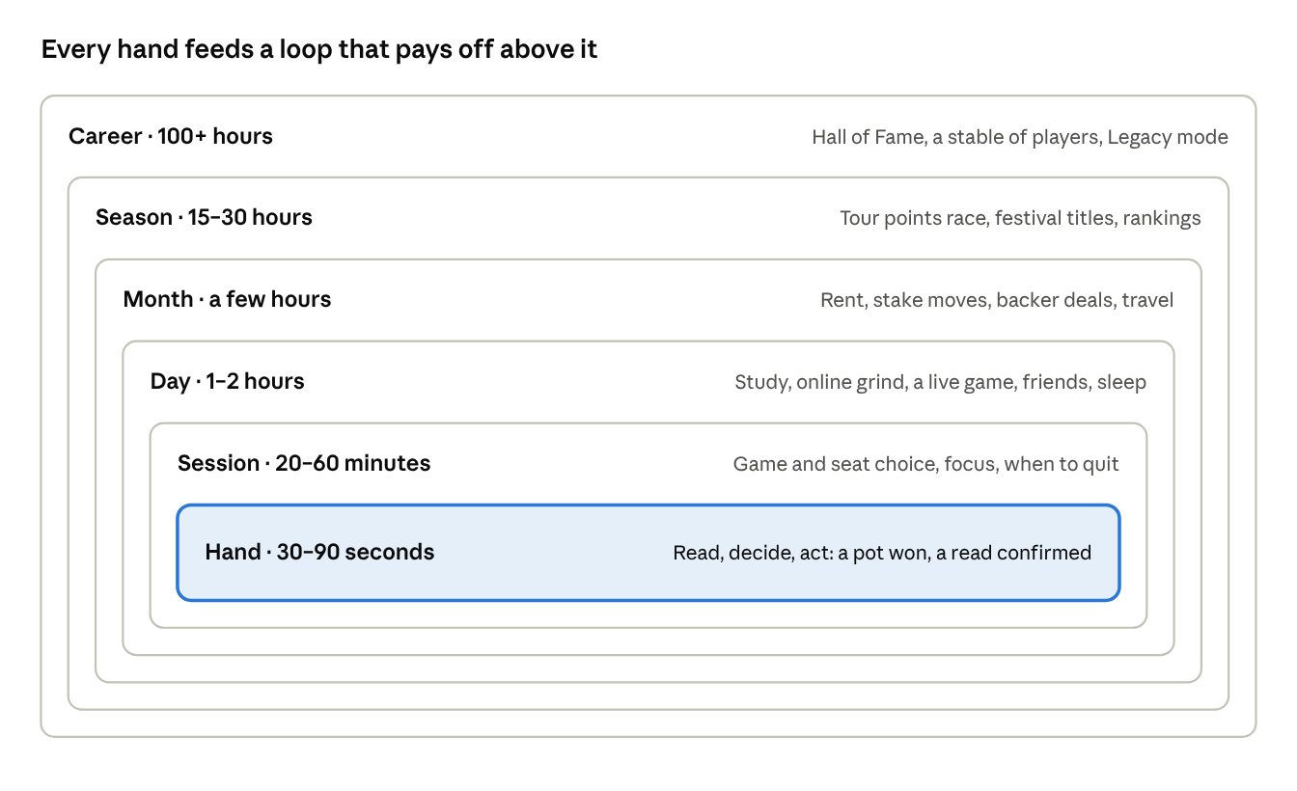
core loops · six nested timescales
Times are pacing targets in real play time; each ring’s payoff is what keeps the ring inside it worth grinding.

Why the grind stays fun
- Real variance is the variable reward. Poker already has one of the most compelling reward schedules in any game. The job is to frame it, not fake it.
- The all-in EV line. Every session graph shows actual winnings next to all-in-adjusted winnings. Running $400 below EV tells players they played well; running above tells them to stay humble. Real grinders obsess over this line.
- Three goals on screen, always. One for tonight (win 3 buy-ins, survive to Day 2), one for this month (move up to $1/$2), one for the career (a Crown Ring). Never zero, never ten.
- Visible mastery. Your leak list shrinks. Your win rate by position climbs. A clean stat page is a trophy.
- The stake ladder is a physical ladder. Each stake has its own room, cast and look. Moving up means a new building, a nicer chair, better chips.
- Multi-tabling as a skill unlock. Online, you start on one table. Perks raise it to 2, 4, then 6 tables on a monitor rig that grows in your apartment. The grinder fantasy is literally more tables.
- Fast-fold pools for nights when you just want volume.
- Quitting is a decision. Leaving while ahead or cutting losses is part of the Discipline tree, and the session recap grades it.
- Skip the dead time. Folded hands fast-forward at the player’s choice, live and online, so the grind never feels padded.
- Hand of the Session. Each recap auto-clips your biggest or best-played hand for the replay library.

Poker realism
Realism comes from three places: the full catalog of games, the procedures of real card rooms, and the human texture of live play.

Games and formats, unlocked over the career
Format | Where it appears | Why it matters
No-Limit Hold’em cash | Everywhere | The backbone of the grind
Hold’em tournaments and Sit & Gos | Online, card rooms, festivals | Career-defining scores
Jackpot Sit & Go (3-handed, random prize pool) | Online sites | Pure adrenaline, huge variance
Pot-Limit Omaha, 4 and 5 card | Mid-stakes live, high-stakes online | A second mastery track for grinders
Short Deck (6+) | Jade Bay private games | High-roller exotic
Stud, Razz, 2-7 Triple Draw, HORSE, 8-game | Mixed-game rooms, late career | Prestige; the Players’ Championship
Open-Face Chinese | Backrooms, side bets between pros | A social minigame
Heads-up challenges | Rival grudge matches | Story climaxes

Cash-game texture
- Rake by venue: a percentage with a cap in card rooms, time collection in high-stakes rooms, a host “tip” in home games, rakeback tiers online.
- House games: straddles (under the gun, button, Mississippi), bomb pots, run it twice, rabbit hunting, seven-deuce bounties, high-hand boards and bad-beat jackpots.
- Room logistics: waitlists, must-move tables, seat and table changes. Seat choice matters — sitting to the whale’s left is worth real money.
- Etiquette with teeth: min and max buy-ins, going south with chips (ratholing) costs reputation, missed blinds, dead buttons.

Live procedure and rulings
- A Floor system on a fictional rulebook modeled on real tournament-director conventions: verbal action is binding, string bets, the one-chip rule, acting out of turn, exposed cards, misdeals.
- Angle-shooters exist. NPCs hide big chips, fake a check out of turn, or reach for chips to induce a fold. Call the floor, or angle back at a reputation cost.
- Counting is physical. Stacks sit in 20s. You can ask “how much?” or request a dealer count. Big chips can be tucked behind small ones.

Online texture
- Time banks, disconnect protection, pre-action buttons, chat, and lobbies whose traffic follows the clock across time zones.
- A tracking-software purchase unlocks the HUD — an in-world tool, not a free overlay.
- Site-level threats: bot rings and collusion teams exist and can be spotted in your own database (see Characters and Surprise features).

The human texture
- Tells through a deliberate tell channel. NPC tells come from their own hidden state, filtered by archetype, skill and noise. Weak players leak honestly. Strong players leak rarely and sometimes reverse-tell.
- Tell vocabulary: bet timing, chip handling, glancing at chips when the flop lands, breathing, neck pulse, posture, staring versus looking away, speech patterns, a shaking hand on a big bet.
- Table talk. A dialogue wheel lets you needle, fish for information, or stay silent. Talking costs Composure; silence gives less away. NPCs speech-play you too.
- Honest variance. Win rates are shown in big blinds per 100 hands. Good players have downswings of 20+ buy-ins. The game shows this plainly instead of hiding it.

RPG character systems
Stats change what you know, how long you last and what you can do — never what gets dealt.

Core attributes
Attribute | Grows by | What it does
Reads | Live hands, dealing shifts, the Reader tree | Tells appear clearer with fewer false signals; subtle tells become visible
Theory | Study sessions, fixing real leaks | Unlocks overlays: pot odds, equity against a range, ICM pressure, a range visualizer
Composure | Surviving beats, mental-game coaching | Tilt builds slower and drains faster
Stamina | Sleep, fitness, diet | Longer sessions before fatigue sets in
Presence | Table talk, TV time, streaming | Stronger speech-play, sponsor appeal, NPC respect
Discipline | Honouring stop-losses and bankroll rules | Resists tilt temptations; better session grades

Tilt clouds, it never controls
Tilt never takes the controls away. It damages information and adds temptation.
- Built by bad beats, coolers, needling, losing streaks, fatigue, hunger and jet lag.
- Low: a faint heartbeat under the mix.
- Medium: a vignette, a shrinking time bank, flickering overlays, tells that throw false positives.
- High: tilt whispers — intrusive prompts urging you to reload, move up or call light. Ignoring them builds Discipline.
- Recovery: a walk outside, a breathing minigame, a call to a friend, a meditation perk, or simply leaving.
- NPCs tilt too. A strong reader sees it, and can exploit it.

Five skill trees
- The Grinder — multi-tabling, stamina, rakeback, fast-fold efficiency. Capstone Machine: no fatigue for the first 8 hours of a session.
- The Reader — tells, speech-play, spotting reverse tells. Capstone Soul Read: once per session, a slow-motion window shows an opponent’s confidence as weak, medium or strong, with a small error rate.
- The Theorist — the Study Lab, range tools, an ICM calculator for tournament breaks. Capstone Equilibrium: solver baselines appear in study replays (never at a live table).
- The Hustler — underground access, prop bets, networking, staking deals, spotting cheats. Capstone Everyone Knows Your Name: standing invitations to private games.
- The Showman — media, streaming, sponsors, TV-table presence. Capstone Main Character: more feature-table seats, and your fame pulls whales into your games.

The Study Lab: the game teaches real poker
- The game analyzes your actual hand history and finds real leaks: “You fold to river raises 78% of the time,” or “You open too wide from early position.”
- Each leak becomes a drill, built from spots in your own hands.
- Fixing a leak in practice raises Theory, so the stat and your real skill rise together.
- Coaches specialize: a tournament coach, a PLO coach, a mental-game coach.
- The forbidden tool. Illicit real-time-assistance software exists in the world. Using it online boosts results and risks a ban, a frozen balance and a public scandal — just like real poker.

Lifestyle sets your ceilings
Sleep, food, fitness, relationships and travel set your Stamina and Composure caps. A pro who sleeps four hours before Day 2 plays Day 2 worse. The gym is a real poker-pro habit here, not filler.

Reputation, four separate meters
- Image — how loose, tight or aggressive opponents think you are, built only from what they have seen.
- Fame — your media and rankings profile.
- Integrity — angles, slowrolls and unpaid debts drag it down.
- Street cred — your standing in the underground.

Bankroll and economy
Money is the save file of your career: two separate pools, real obligations, and many ways to get backed, go broke and climb back.

Two pools
- Poker roll — buy-ins only. A Bankroll Advisor app on your phone suggests stakes (for example, 30+ buy-ins for cash games) and flags shot-taking.
- Life roll — rent, food, travel, coaching, software, tips. Raiding the poker roll for rent is allowed, and it stings.

Getting money
- Staking and backing: sell action at a markup, take a backing deal with makeup (losses carried until you profit), swap percentages with friends at festivals.
- Running a stable: late game, you back NPC players. Their results run through the same simulation, so a horse can win a major or drop 60 buy-ins. A management layer on top of poker.
- Sponsorships: patch deals, site ambassador contracts with volume requirements, streaming deals.
- Prop bets (see Surprise features).
- Dealing shifts: the always-available comeback path. Steady pay, and every shift earns Reads XP from watching the table.
- Loans: from friends (relationship cost), a backer (makeup), or an underground lender (street-cred cost, collectors, forced appearances in his game).

Spending money
Rent and apartment upgrades, flights and hotels, coaching, tracking software, buy-ins, dealer tips, taxes and gifts. Tipping builds staff goodwill: waitlist priority and faster table changes, never better cards.

Online sites (all fictional)
Site | Traffic | Rake | Game quality | Risk
RiverKing — big regulated site | Huge | High | Tough regulars | Very low
Flop Social — recreational app | Medium | Medium | Soft | Low
Chainpot — offshore crypto site | Medium | Low | Very soft | High: coin swings, slow withdrawals, possible collapse
The Clubhouse — private club app | Small | Varies | Soft to shark-infested | Collusion rings
- Site risk is real. A world event can freeze a site overnight and lock balances for months. Keeping everything on one site is its own gamble.
- Taxes by country. Some fictional countries tax winnings and some don’t, so tax planning shapes where you play.

Economy guardrails
- Every source has a sink. Festival buy-ins scale with the stages of your career, so the top stays hard.
- The game never creates money to rescue you. Comebacks are earned through dealing, backing and small stakes.

Open world
Build a handful of dense, walkable districts connected by travel, not one seamless continent — density is what makes a poker world feel alive, and it keeps scope sane.

Cities (all fictional)
City | Vibe | Poker identity | Unlocked by
Harbour Point (home) | Rainy port city, neon diners, laundromats | Bar leagues, a small card room, a laundromat backroom game | Start
Neon Mesa | Desert gambling capital | A dozen rooms, 24-hour games, the Crown Championship | First live festival
Delta Circuit | River towns and a paddle steamer | Road-gambler games, mixed games | Mid career
Frostvik | Nordic winter festival town | Online-grinder crowd, saunas, a snowbound Main Event | Online fame
The Meridian | Cruise ship | Seats won through satellites, sea-day marathons | A satellite win
Porto Sol | Mediterranean marina | Superyacht games, the High Roller Classic | Fame threshold
Jade Bay | High-rise harbour hub | Short Deck, private whale games, enormous stakes | Invitation only

Venues you can walk through
- Get on a list with the brush, rail a table to scout it before sitting, check the high-hand board, cash out at the cage.
- High-limit rooms are gated by bankroll and reputation. The door host learns your name once you belong.
- Every room has a personality: the tourist room with soft games, the grinder room full of regulars, the old-timers’ room with slow limit games.

Underground and private games
- Found through relationships and rumors, never marked on the map from day one.
- Settings: a loft above a restaurant, a warehouse, a basement bar, a mansion, a yacht.
- Risks: raids, robberies on the walk home (take a cab, or hire security later), and cheating hosts. All non-graphic and felt through consequences — lost cash, lost trust, lost access.

Home base
Your apartment grows from a basement studio to a penthouse. The study desk visibly grows from a laptop to a six-monitor battlestation. A trophy wall, a home gym, a card table for hosting.

Between sessions
Gym and running, cooking, nightlife networking, golf and pool (prop-bet venues), friendships and dating, mentor meetings, forum browsing, streaming.

A living world
- NPC careers run offscreen. Pros have schedules, bankrolls and stake levels. They move up, go broke, marry, retire.
- PokerWire and The Rail. An in-game news site and forum react to results — including yours, sometimes with terrible takes. A viral bad beat earns fame; a bad slowroll earns a nickname.
- Rumors point to new games: “There’s a whale at the Mesa Grand every Thursday.”
- Real rhythms: paydays and holidays bring recreational players, big sports weekends fill rooms with tourists, rainy nights pack local card rooms, and 4 a.m. games are the softest and the most dangerous.
- The phone is the hub: messages, map, bank, staking app, forum, news, flights.

Characters and AI
Opponents remember you, adapt to you and become rivals on their own — that is the engine of emergent stories.

The memory system
Every NPC keeps a compact memory of you:
- Observed stats — only public information, so the information firewall stays intact.
- Showdowns seen — “He bluffed me with 7-2 at the Mesa in March.”
- An emotional ledger — slowrolls, needling, generosity, respect.
- Big pots between you, stored as hands for later callbacks in dialogue and news.
Rivalries trigger from threshold events: a huge pot, a public needle, a bad beat on a big stage. Rivals follow you to festivals, post about you on The Rail and challenge you to heads-up grudge matches.

Opponents that adapt
- NPCs model you from what they observe and adjust. Low tiers barely adapt; high tiers adapt fast and exploit patterns.
- 3-bet light every orbit? The regulars start 4-betting you. Never bluff rivers? They fold to every river bet you make.
- Predictability gets expensive and changing gears pays off — exactly how real poker feels.

A starter cast (all original)
Character | Archetype | Role in your story
Duke Marlowe | Old road gambler in his 70s | Mentor for reads, integrity and underground access
Nadia “The Professor” Okafor | Theory-perfect online legend | Theory mentor, later a final-boss rival
Big Sal Ricci | Loud, rich recreational whale | The game everyone wants a seat in
June Albright | Grandmotherly, rock-tight regular | Gatekeeper of the local card room; underestimate her at your peril
Mika “Nitro” Vance | Hyper-aggressive 20-year-old | Your first big rival
Vera Lindqvist | TV-savvy pro who needles | Media rival and sponsor competitor
“Ghost” | Anonymous online legend | Mystery arc; never seen live until the end
Teo Park | Your best friend and swap partner | Travels with you; his career can soar or crash

Protect the game
Whales have a fun meter. Needle them, tank every decision or berate a bad call, and they leave — taking the whole table’s profit with them. Keeping the fun player happy is a real pro skill, and the game rewards it with invitations.

Your crew
Friends, a partner, a roommate. They have lives: a friend asks for a loan, a partner resents a six-week festival trip, a swap partner goes on a heater. Healthy relationships raise your Composure cap and open story missions.

Huge tournaments
Tournaments are the peaks of the career: a ladder from freerolls to a 10,000-player Main Event that runs across a week of in-game days, with every chip in the room simulated.

The ladder
- Online freerolls and micro-stakes tournaments.
- Sunday majors online and local deepstacks.
- Regional circuit events that award Tour points.
- International festivals: weeks of side events, cash games and parties.
- The majors: Main Events, High Rollers, the Players’ Championship.

The majors calendar (fictional)
Event | City | Buy-in | Field | Signature
Crown Championship Main Event | Neon Mesa | $10,000 | 10,000+ | 7 days, 4 starting flights, the Crown Ring
Crown Mystery Bounty | Neon Mesa | $1,000 | 15,000+ | Envelope bounties, one worth $1M
Porto Sol High Roller Classic | Porto Sol | $100,000 | 150 | Final table on a superyacht
Jade Bay Super High Roller | Jade Bay | $250,000 | 60 | Invite-only, Short Deck side events
Players’ Championship | Delta Circuit | $50,000 | 100 | 8-game mix
Frostvik Winter Main | Frostvik | €5,300 | 2,000 | Full of online qualifiers
Meridian Sea Classic | The Meridian | $3,500 | 800 | Seats mostly won through satellites
The Long Night (cash marathon) | A private mansion | $500,000 minimum | 8 | A 30-hour live cash game

Structure realism
- Starting stacks, 60–120 minute levels, a big-blind ante, breaks and a dinner break.
- Starting flights, late registration and re-entry windows.
- Bag and tag at the end of each day, with your count on the live chip-count feed.
- Redraws for Day 2, table breaks, color-ups and the chip race.
- Hand-for-hand on the bubble, roughly 15% of the field paid, sharp pay jumps.
- ICM pressure, final-table deals (ICM or chip chop), and heads-up for the title.

Satellites: the dream path
Step satellites and mega-satellites turn $5 into a Main Event seat. Satellite bubbles teach the strangest real poker skill: folding aces because your seat is already locked. The online qualifier who wins it all is the heart of the fantasy.

Bounties
Progressive knockouts (half of each bounty lands on your own head), mystery bounties with an envelope-reveal ceremony, and bounty-hunter events where your rivals are worth extra.

Festival life
Twelve-hour days, hotel bills, jet lag, busted friends, swaps, sweating each other on the rail, parties that cost Stamina. A deep Main Event run is also an endurance run.

Broadcast mode
- A feature table with delayed hole-card cams, commentary and a crowd on the rail.
- Procedural commentary driven by engine events: stack depth, pot odds, history between the players.
- A heart-rate readout for every finalist, driven by Composure — yours included.
- A final-table walk-on, a lighting change, and a ring ceremony cinematic.

Simulating 10,000 players: Poker LOD
Treat simulation fidelity like rendering LOD: only your table needs full fidelity, and every other table gets the cheapest simulation that still produces honest results.
Tier | Which tables | Simulation | Rendering
0 | Your table | Full engine, full AI, real time | Full MetaHumans
1 | Visible neighbours and the feature table | Full engine, cheap archetype AI | Low-cost animation
2 | Tables holding named NPCs | Full engine headless, fast heuristics on worker threads | None
3 | Everything else, and all tables during time skips | Statistical chip-flow model per level | None
- Named rivals and your stable always sit at tier 2 or better, so their bust-outs produce real hand histories you can read on PokerWire.
- A seed per table means any hand can be replayed.
- Table balancing and breaking follow real tournament-director logic inside the C++ core.
- When you bust or wait out a break, the sim fast-forwards and promotes or demotes tables on the fly.

Surprise features
These are the features that make people post clips and tell their friends.
- Provably fair shuffles. Before each hand, the game publishes a hash of that hand’s shuffle seed. Afterward it reveals the seed, and anyone can verify the deck with a public tool. The Honest Deck becomes something players can check, not just trust.
- The Multiverse River. After a big all-in, an optional cinematic runs the board 1,000 times in a blur and lands on the result: “You win this in 81% of universes.” Bad beats turn into understanding.
- The Mirror. A boss fight against yourself. The game builds an opponent from your own hand history — your frequencies, your leaks — and you play it heads-up. Beating your past self proves you improved.
- Honest Tells mode (optional). The AI reads you: decision time, snap-calls, hesitations, where your camera looks in live mode. Strong opponents exploit your timing. Balance it to beat them.
- Marked, the cheating-ring arc. A noir storyline. A private game runs marked cards and a collusion team; an online site hides a “superuser” account. The house deck is always fair — the cheaters use in-world methods you can detect. Gather evidence from your database (impossible win rates, never folding when behind), then choose: expose them, leverage them, or join them.
- Legacy mode. Retire your character and they become an NPC mentor in a new career, with their real stats, stories and grudges. You start as their protégé; their card protector is your heirloom.
- Home Game Builder. Host games in your apartment: stakes, guest list, food, music, table size. Good hosting builds your network, a great game draws whales, and a legendary game earns a nickname on the forum.
- Streaming career. Go live. A procedural chat watches your hands on delay, backseats, donates and trolls. Viewer count and chat mood follow your reputation.
- Prop bets. Real poker culture as minigames: a golf putting bet, a free-throw bet, a month-long fitness bet with a rival, a no-phone-for-30-days bet, a walk-across-the-city bet.
- Black Tuesday. A world event shuts a major online site overnight. Balances freeze and the meta shifts to live play for a season. Players who spread their money laugh; the rest go dealing.
- Hand of the Year awards. At season’s end, a ceremony nominates the year’s best hands — yours and the NPCs’ — voted by the in-world community on drama and quality.
- Physical card peeking. In live mode, hold a button to cup and peek at your cards. Squeeze the river slowly on an all-in. Learn chip tricks as a Presence minigame.
- Rail your friends. Once you bust, walk the tournament floor, find friends’ tables, sweat their all-ins live and buy them dinner on the break.
- Ghost is someone you know. The anonymous online legend is procedurally picked from the NPCs you share the most history with, so every playthrough reveals a different person.

Graphics, animation and audio in UE5
Spend the realism budget where the eye goes at a poker table: faces, hands, chips and felt.

Lighting and environments
- Lumen for casino interiors full of emissive signage; hardware ray-traced reflections on polished floors, glass and lacquered rails at high settings.
- Nanite for dense environments (casino decor, city blocks) and World Partition with HLODs for the districts.
- PCG graphs to dress casino floors and streets, so new rooms are fast to build.

Faces and tells
- MetaHuman for every opponent (MetaHuman creation lives inside the engine as of UE 5.6).
- A tell layer of additive facial animation: blink rate, lip press, swallowing, jaw tension, gaze aversion, neck pulse, breathing rate. The NPC’s tell channel drives the blend weights.
- High Reads lets the camera focus-pull onto a face. The micro-expression is really there on the model, not a UI icon.

Hands, chips and cards
- Control Rig with hand IK for chip grabs, pot pushes, card peeks and mucks; motion-captured chip tricks and shuffles.
- Chip stacks as instanced meshes, switching to Chaos physics only while chips move (pot pushes, spills, a stack knocked over on tilt).
- Materials: felt with fabric sheen, clay chips with edge spots and inlays unique to each casino, card stock that bends and catches light, worn and nicked decks in underground games.

Crowds and camera
- Mass Entity for casino-floor crowds, with cheaper animation for distant tables.
- A seated first-person camera with subtle breathing, which gets heavier and narrower on tilt.
- A Sequencer-driven broadcast director for replays and final tables.
- TSR by default, with DLSS, FSR and XeSS as upscaling options.

Audio
- MetaSounds for procedural chip clacks by chip material and stack size, card snaps and felt slides.
- Room tone that scales with occupancy: crowd murmur, distant casino ambience, a neighbouring table’s gossip you can overhear.
- Music intensity tied to pot size relative to your stack. A heartbeat and a thin high tone under tilt.

Pipeline
Blender for chips, card backs, table sets, props and apartment interiors, with scripted batch export and validation into UE.

Compelling without being predatory
Aim for “one more session” because the player wants it, never because the game trapped them — which also keeps the rating and legal picture clean.

Hooks that respect the player
- The stake ladder, festival calendar and Tour race give long goals; the three on-screen goals give short ones.
- Collections: card protectors, chip sets from every casino, trophies, rings, and legendary hands in a replay library.
- Streaks tied to good habits (study days, stop-losses honoured), never to logins.
- Emergent stories — rivals, comebacks, bad beats — are the strongest hook of all, and they cost nothing.

Lines not to cross
- No selling chips or bankroll for real money. That turns a career RPG into a social casino, a category regulators watch closely.
- No loot boxes, no fake near-misses. The Honest Deck already rules out the second.
- No punishing absence — no decaying rewards, no “your streak dies tonight.”

A business model that fits
A premium price, then expansions that add real content: a new city, a new variant, a new festival. Cosmetic packs (card backs, chip sets, outfits) are fine when bought outright.

Ratings
Realistic simulated gambling draws a content descriptor and often a higher age rating. Check current ESRB, PEGI and regional rules before locking features, especially anything involving purchases.

Healthy-play touches inside the fiction
- Your partner texts after a long session: “Coming to bed?” Taking the break restores Composure.
- Session recaps show real time played alongside in-game time.
- An optional story thread about a friend drifting into pit games — handled with care — draws the line between a skill game and a compulsion.

Fitting it into the Poker Life architecture
Every idea here keeps your existing rules: the poker engine stays engine-independent C++, the AI sees only public information, and nothing favours the player.
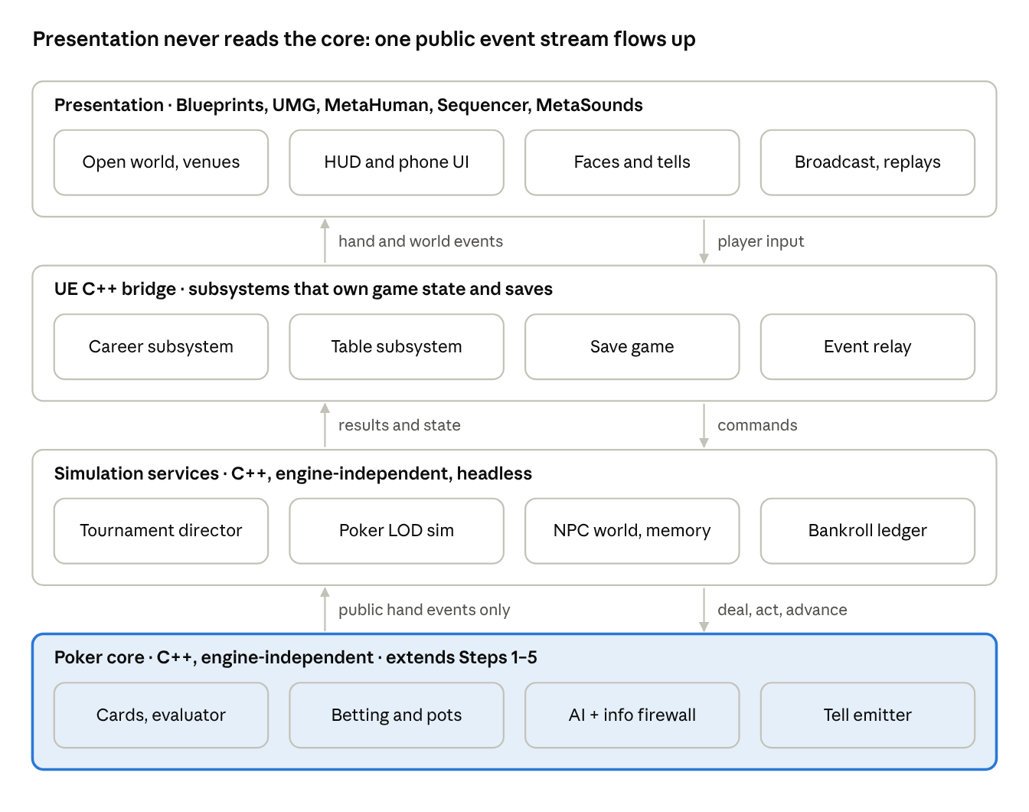
architecture · four layers and what flows between them
The core never calls upward; every layer above it learns what happened from the same public event stream, which is what keeps the information firewall intact.

Where each system lives
System | Layer | Priority | Depends on
Tournament director: levels, balancing, payouts, ICM, deals | C++ core | Core | Step 6 MTT management
Poker LOD simulator: tiers 1–3, per-table seeds | C++ core, headless | Core | Tournament director
Opponent model of the player (observed stats only) | C++ core | Core | Step 5 AI and information firewall
Tell emitter (NPC side, noisy, per archetype) | C++ core → UE animation | Core | Step 5 AI
Bankroll ledger, staking contracts, makeup | C++ core | Core | Save system
More variants: PLO, Short Deck, Stud, Draw | C++ core | Next | Evaluator, betting engine
NPC memory and rivalry triggers | C++ core | Next | Opponent model
World sim of NPC careers | C++ core, headless | Next | Poker LOD, economy
Commit-reveal shuffle (provably fair) | C++ core | Next | Deck and RNG
Study Lab leak finder | C++ core + UMG | Next | Hand history store
Open-world districts, venues, phone UI | UE: World Partition, Blueprints, UMG | Next | Career subsystem
Broadcast mode and commentary | UE: Sequencer, Blueprints | Stretch | Tournament director events
Streaming chat, prop bets, Legacy mode | Blueprints over C++ state | Stretch | Most of the above

Guardrails that keep it honest
- The tell channel is the only deliberate leak. It lives inside the NPC’s decision module, emits noisy cues, and never reads other seats.
- The player model reads events, not cards. The adaptive AI subscribes to the same public event stream a spectator sees, plus action timing.
- Simulation tiers never touch your table. Tier 3’s statistical model only moves other tables’ stacks.
- One event stream feeds everything. Hand events drive the HUD, commentary, news, forum posts, NPC memory and achievements, so presentation never peeks into the core.
- Deterministic seeds per table make replays, bug reports and provably fair shuffles one system instead of three.

Suggested order once Step 6 is validated
- Tournament director and Poker LOD — the Main Event depends on both.
- Bankroll ledger, staking and the career subsystem.
- Opponent model, tell emitter and NPC memory.
- One city, Harbour Point, working end to end before any other city.
- Broadcast, streaming and Legacy mode last.
Slot these into your existing numbered step plan however it fits best; each one is sized to be reviewed on its own.

